Brief notes before implementing the “diff_priv.sql” file.

**Step1:**

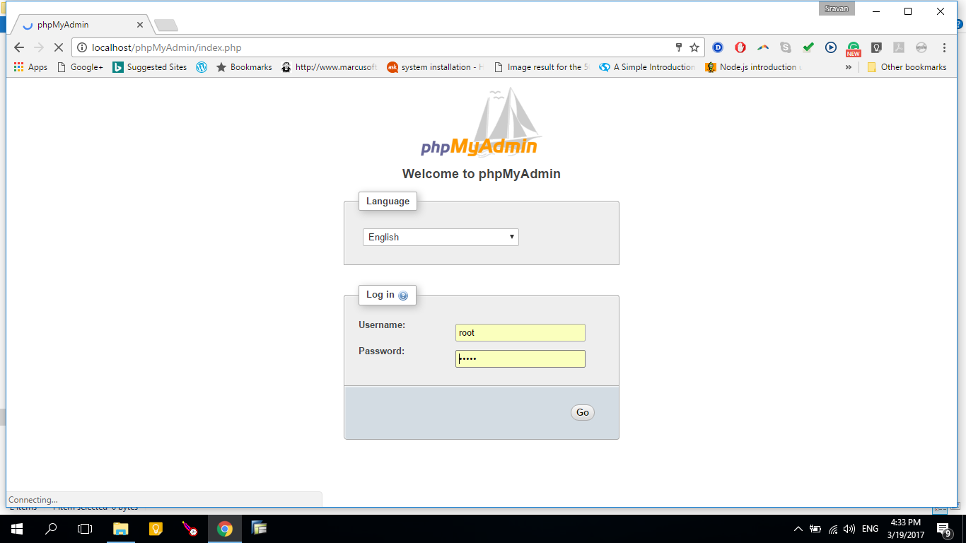

Please make a note of phpMyAdmin Username, Password.

**Step2:**

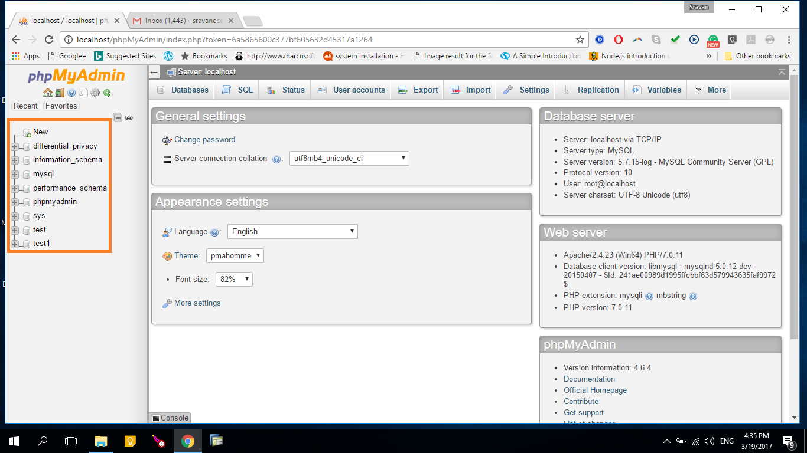

Select any one of the database or create a new database.

Here we use “test” database.

**Step3:**

Click the database name to go into the details and select import header to view the import menu.

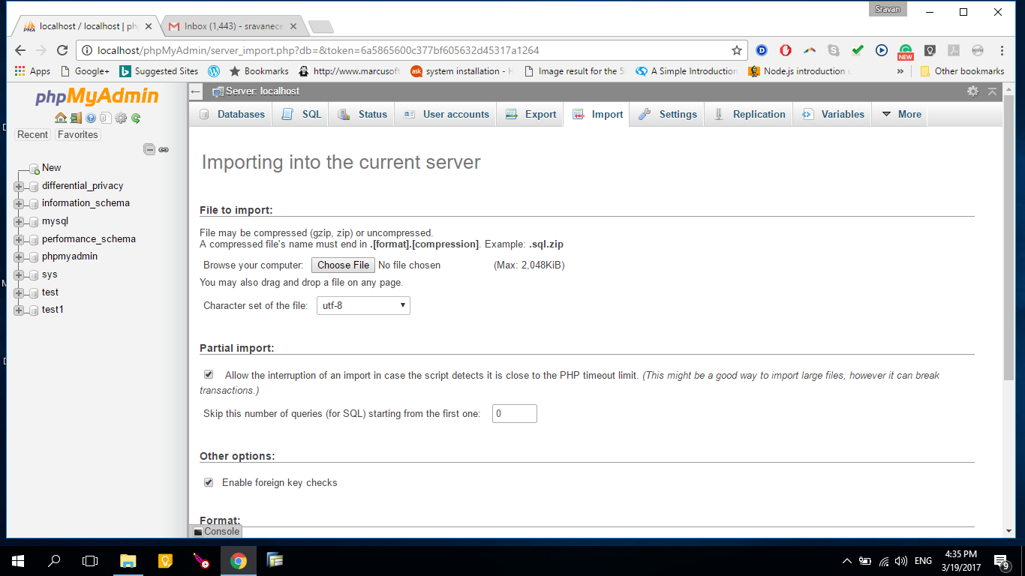

In the import menu, select the *Choose file* button and upload the diff_priv.sql file and select the *Character set of the file*: utf-8.

Scroll down the import menu and click the *Go* button.

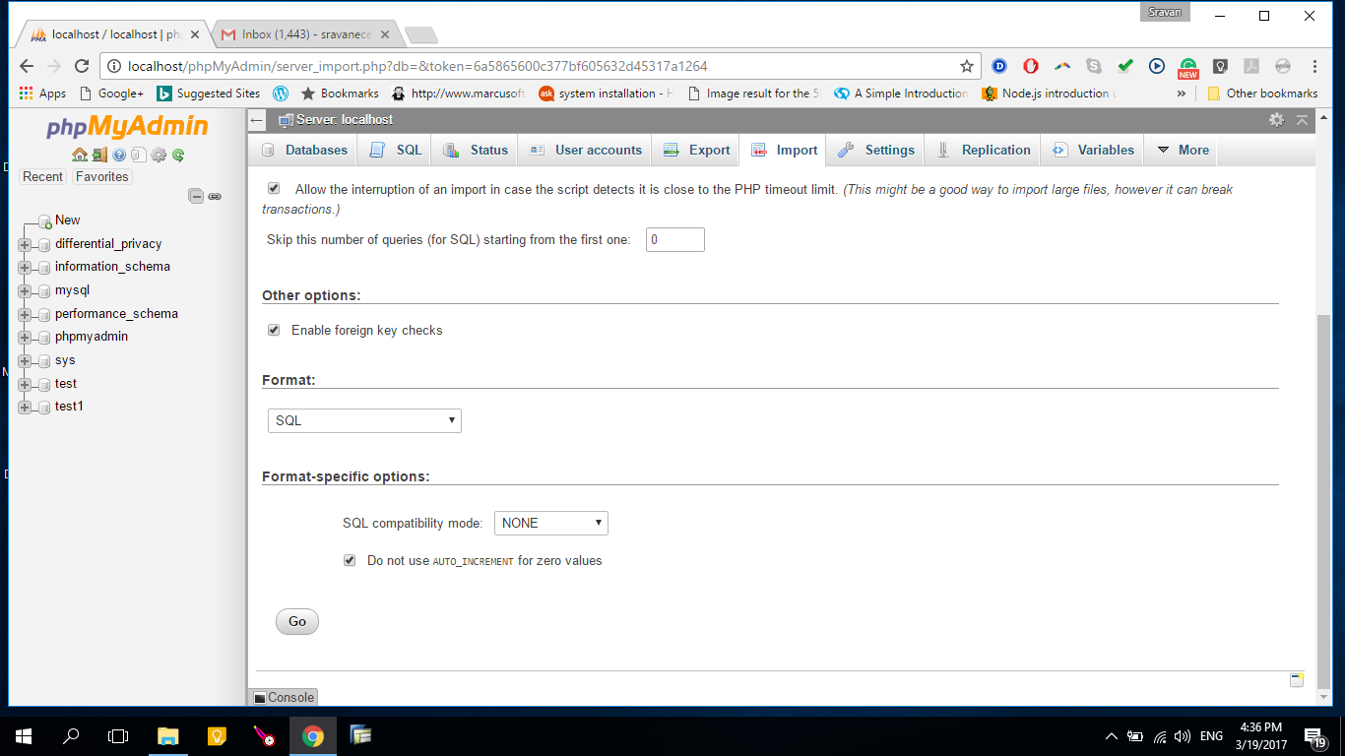

Step4:

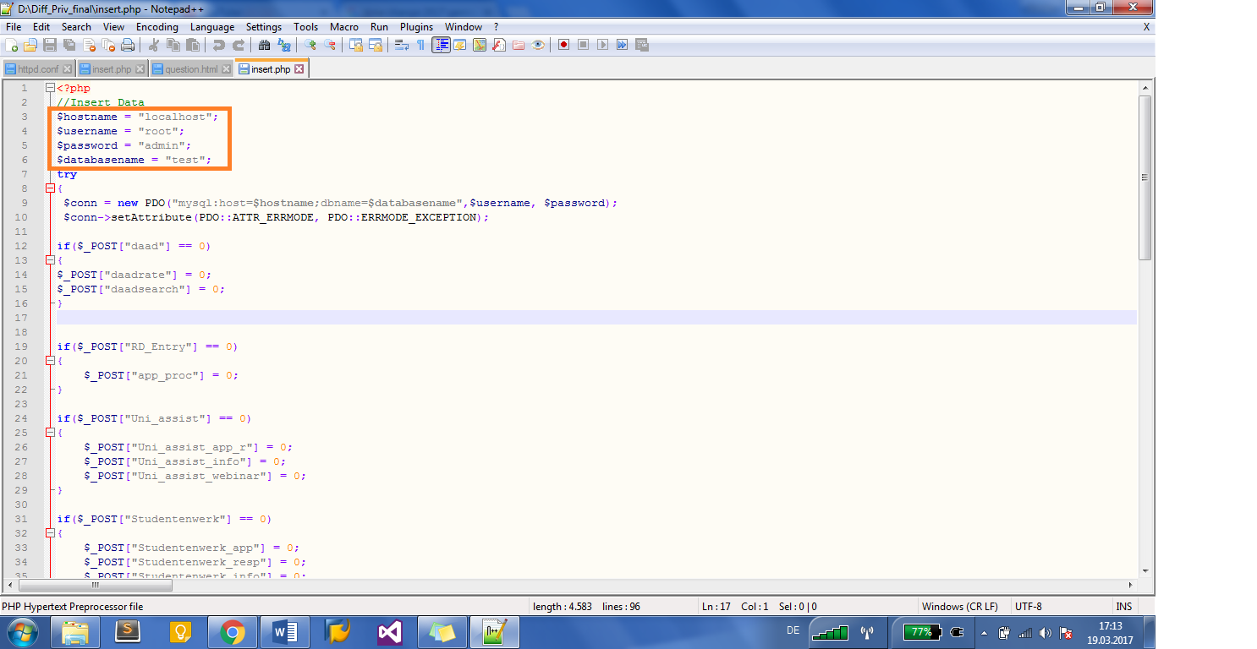

Enter all the values (hostname*, username, password, databasename) from **Step1,2** in insert.php file.

*Here we are using localhost and based on the type of server hostname varies.

**Important Note:**

If we want to change the .sql name, then the following name should be changed with respective as shown below.

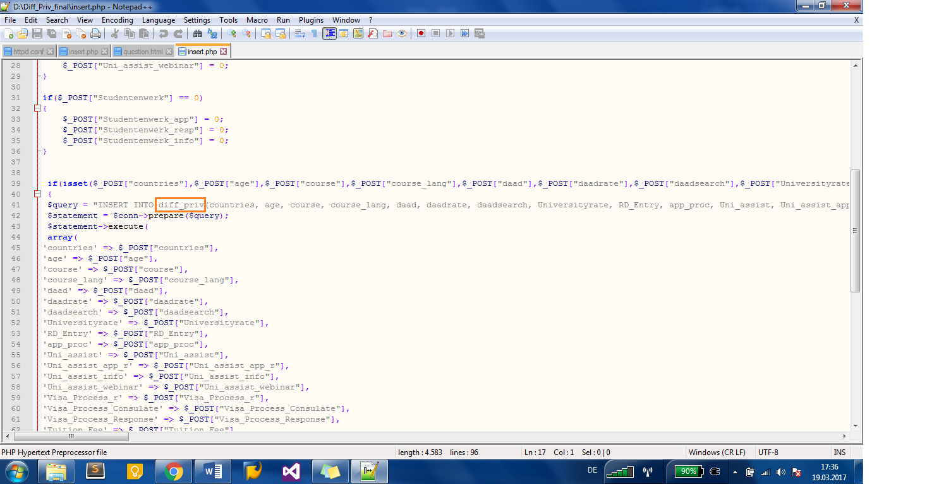

**Save** the file and run the html files.